MySQL Community Edition Download and Install Process

The following is a guide on how to install MySQL on your home computer/laptop. This will be important for practice, and for doing assignments later on.

Go to the following webpage and choose to download the ‘web-community’ installer.

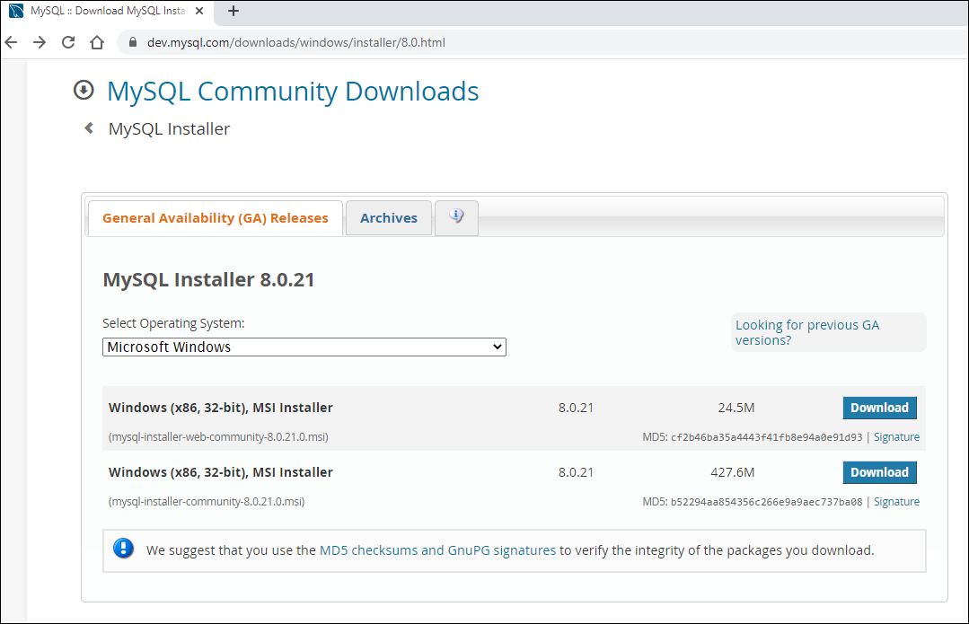

No need to sign up, just start the download..

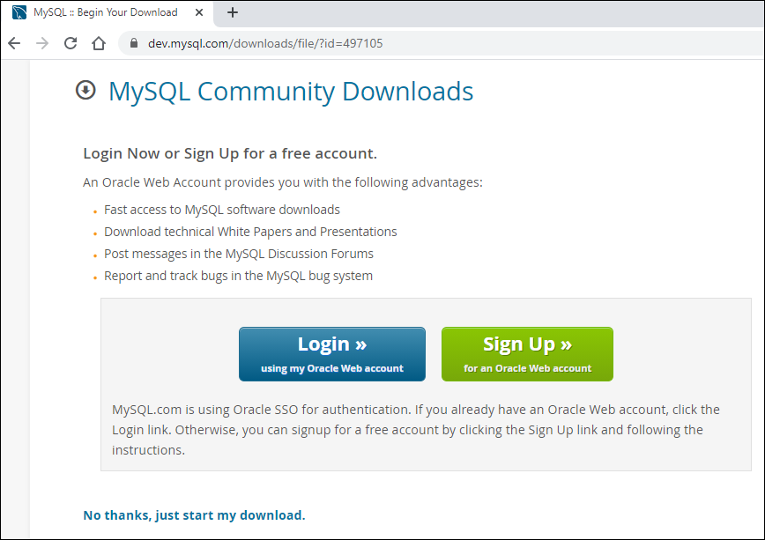

Double click on the installation file to start the installation, and follow the process:

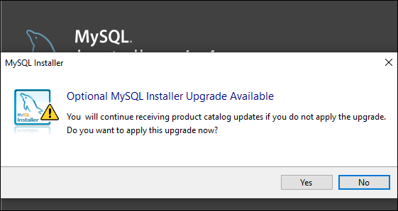

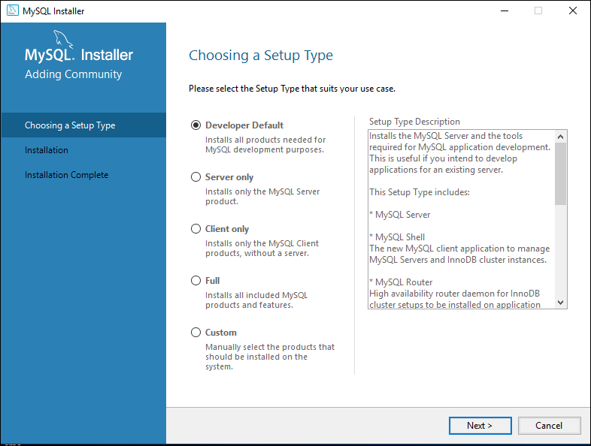

Hit Execute and follow as the dependencies are installed one by one. You may have to accept several license agreements.

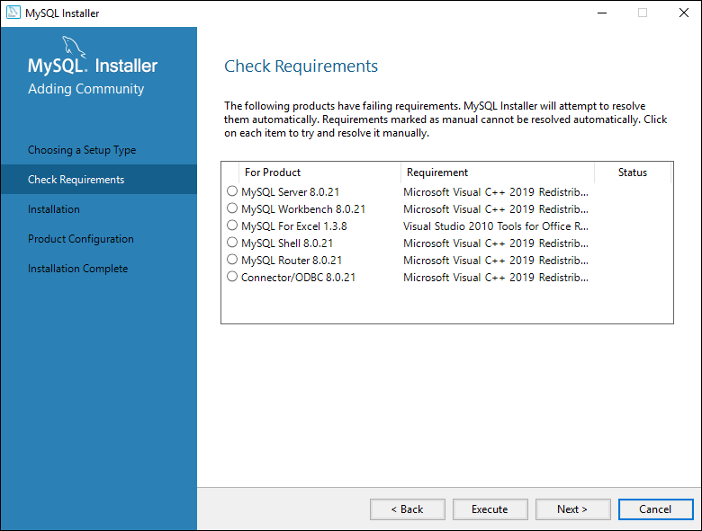

When the status is showing “INSTL DONE” for all the requirements, click next..

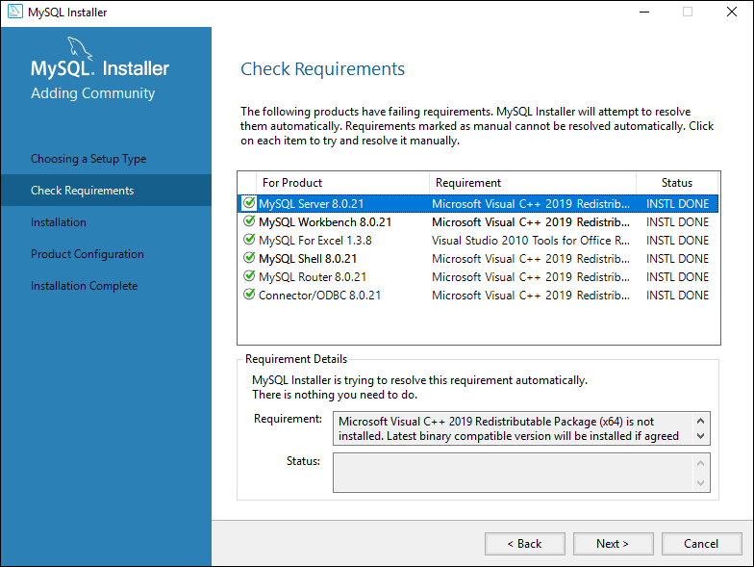

Click on “Execute” to install..

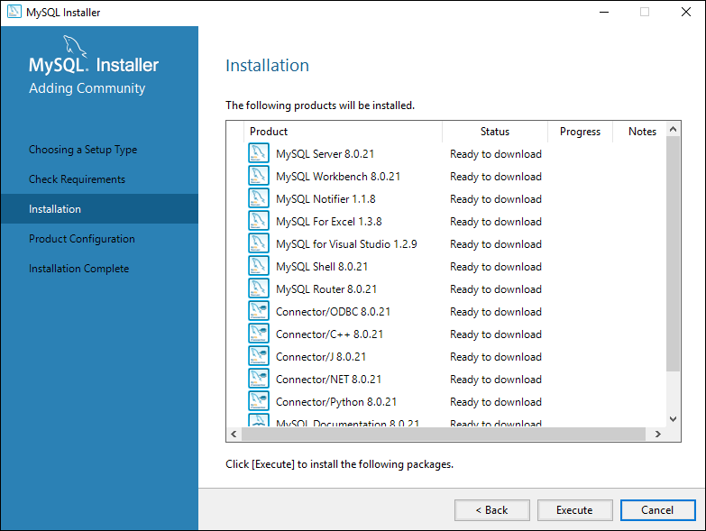

If the status is not showing “Complete”, you may have to choose “Try Again”..

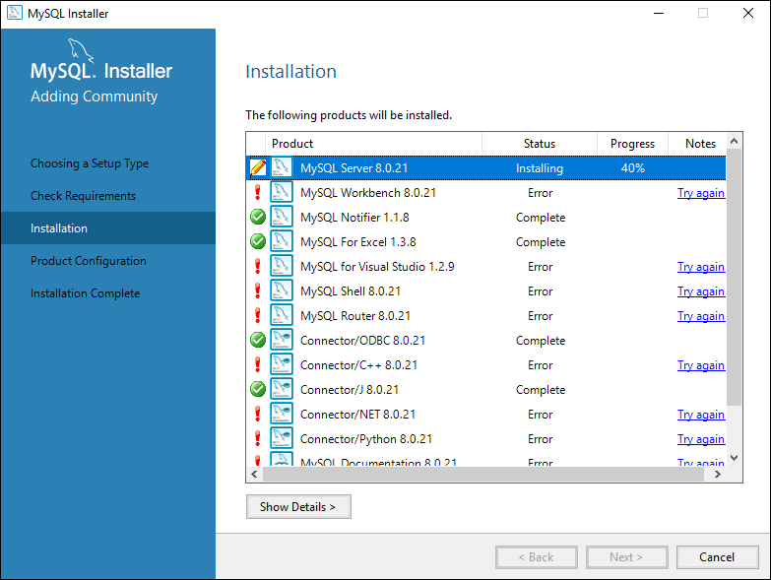

Note: The following pages may differ slightly when you’re doing the installation.

The following default values should be fine:

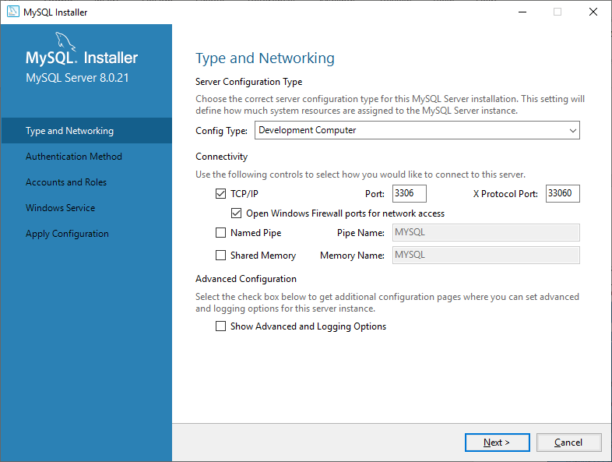

Note the default port that MySQL accepts connections is 3306. Later in the course you’ll have to specify this when connecting from a Java program.

Authentication Method:

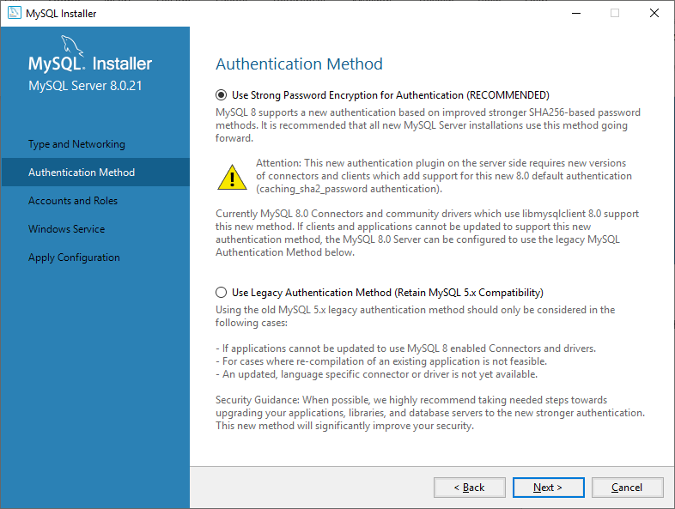

Note: Set the root password to ‘admin’. This will ensure you don’t forget it and your programs will work in the college and at home without modification. Of course, if it was a production environment we’d use a strong password..

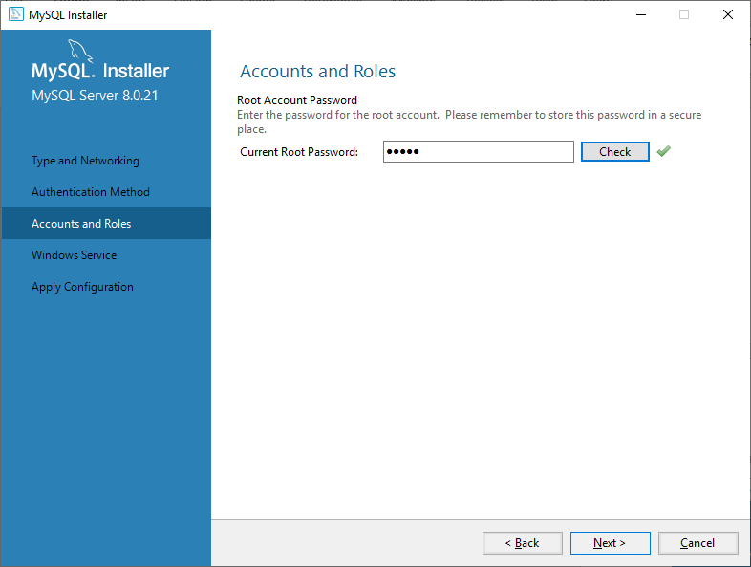

Keep defaults:

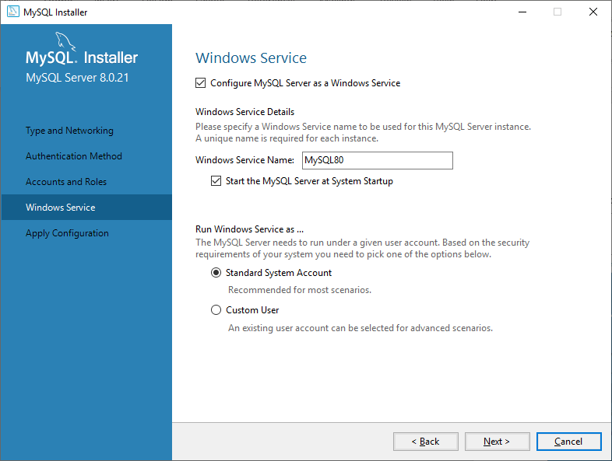

After the installation you should be able to start a command prompt and run the commands in the labs.

